JULY 2015
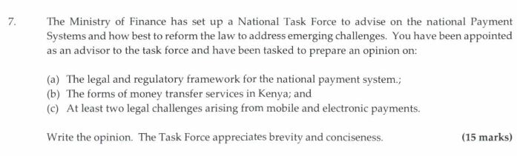
a)
- The National Payments System (NPS) generally is the conduit(s) through which buyers and sellers of financial products and services make transactions and are an important component of a country’s financial system. In Kenya the NPS system comprises of the Central Bank of Kenya, the Government, Commercial Banks, Financial Institutions and Payment System Providers(including mobile service providers)
- The National Payment System Act 2011 was enacted to provide the legal framework for NPS in Kenya. This act makes provision for the regulation and supervision of payment systems and payment service providers, and for connected purposes.
- Additionally the National Payment System Regulations 2014 was enacted to operationalize the NPS Act 2011 and provides for the authorization and oversight of payment service providers, designation of payment systems, designation of payment instruments and Anti-Money Laundering measures.
- It should be noted that the NPS provisions apply hand in hand with the supervisory role of the CBK as per the Central Bank of Kenya Act 2004, Chapter 491 Section 4(A) (2) in subsection (1) (d), which provides the Bank the mandate to exercise the oversight powers of promoting financial stability through cohesion in financial market infrastructure.
- Furthermore mobile payments have transformed the way financial services have been delivered in Kenya, by bringing in a large number of ‘unbanked’ and ‘under banked’ persons into the financial realm. This brings to the fore the importance of establishing a strong consumer protection regime as the mobile payments system in Kenya grows exponentially.
- Digital payments also enable integration with organizational information systems which can help increase efficiency and minimize risks. Take for example the government IFMIS system. The various ministries procure thousands of products and services each day. The NPS thus covers all these players in the payment system.
- Kenya’s payments system has also evolved over time and now operates within robust regulatory and monitoring frameworks, which include the Central Bank Prudential Guidelines and the Proceeds of Crime and Anti-Money Laundering Act.
- Furthermore, the establishment of the Financial Reporting Centre (FRC) reinforces the respective roles of the Central Bank of Kenya (CBK), the Ethics and Anti-Corruption Commission (EACC), the Office of the Director of Public Prosecutions (DPP), and the police service in oversight and addressing illicit flows of funds.
The following are the salient features of the National Payment System Regulations 2014:
- The NPS Regulations require that the funds be diversified across strong-rated institutions. Where the trust funds balances are in excess of KES 100 million the funds will have to be placed in at least two strong-rated institutions with a maximum of 25% of the total trust fund balance held in each institution. Rule 25 (4)
- the NPS regulations have made provision for the application of international standards such as the BIS Committee on Payments and Settlement Systems (CPSS) core principles and the Financial Action Task Force (FATF) recommendations.( Rule 24(b))
- Operators are required to comply with such international standards in addition to any other technical standards that the CBK may prescribe to minimize risk
- The NPS Regulations also prohibit exclusive dealings with agents thus empowering agents to seek contracts with multiple service providers. The agent shall enter into separate contracts with each institution. (Rules 15 (1) and 15 (3)).
- Interoperability: in order to encourage market-led interoperability, the regulatory framework has provided for the recognition by the CBK of a Payment Service Provider Management Body (PSPM). The PSPMB would essentially be a clearing and settlement house for mobile money transactions established and operated by payment service providers, including e-money issuers. It is also intended to act as a channel for communication by its members with the CBK and as a forum through which matters of mutual interest can be addressed.

- National Payments Systems in Kenya are classified into two categories;
- Large Value (Wholesale)- include-Kenya Electronic Payment and Settlement System (KEPSS), Regional Payment Systems
- Low Value (Retail) Payment Systems- include payments cards and mobile money transfers

- Challenges
- Cyber Security- Computer- Discuss the Crime Misuse and Cyber Crimes Act 2018. Discuss how the advent of Block chain technology can enhance security.
- Data use and Protection- Discuss the Privacy and Data Protection Bill. A good example of data breach would be the Cambridge Analytica case.
- Consumer rights awareness- Lack of awareness of rights by consumers
- Fraud and Money Laundering- Discuss the NYS case

